**Design Document**

Squirrel Scamper

Greg Schoeninger

October 22, 2012

CSCI448 Android Programming, Fall 2012

Colorado School of Mines

**Application Declaration**

Squirrel Scamper is a game where the user will take action as a squirrel that climbs a tree. The user will control the squirrel with the accelerometer, and along the way will collect objects, avoid objects, with the objective of getting as high as possible without a mistake.

**Application Definition**

In Squirrel Scamper, the user will control a squirrel that is climbing to the top of a tree. Along the way there will be acorns you can collect, and objects you must avoid such as holes in the tree, birds, patches of sap, etc. The objective is to get as high as you can on the tree without hitting anything hazardous, while collecting as many acorns as possible. You will also be able to shoot the acorns you collect back at the enemy birds as they come down at you. Sap will slow stop you in place for a period of time subjecting you to bird impact, and bird or impact with a hole will end your scamper and you will have to start from the ground again. I plan on having local high scores on the device stay on the device as well, and to flash a high score banner quickly at the top if you surpass you old high score.

**User Story**

Meet Fred, the underachieving CU student who never pays attention in class. Fred loves his droid and playing games in class to pass the time. He thinks lectures are boring and won't matter in the real world, but that bird flying into pigs is just the best thing ever. He finally gets sick of the birds because they are just so angry all the time and finds a new game called Squirrel Scamper. He giggles at the delightful name. As soon as he opens the app he realizes the volume on his device is all the way up and the cartoony tune is blasting in the middle of his sociology class, everyone stares. He quickly looks down and sees a button that looks like a speaker and taps it furiously. The sound turns off and on over and over again before he realizes tapping multiple times will not help the situation and he leaves it in the sound disabled mode.  
  
He then sees a few options: Play, Highscores, and Help. "Psht, Help?", he thinks to himself, "I am a natural at all games", and hits play. He now sees a Squirrel quickly scampering up a tree passing shiny acorns as he goes. He then thinks to himself, "Hey that music was kind of catchy at the beginning, good thing I brought headphones", and quickly pops them in and presses the speaker that is still on the screen. The catchy tune starts playing again. He now wonders why the Squirrel seems to be clining the left side of the tree and tilts his device to see if it has any effect.. "Aha!" he exclaims not realizing his headphones are in (everyone stares again), the squirrel moves to the right and he hits an acorn. Bling! Chimes the app as he sees his score rise with each acorn he collects. "This is kind of fun..", he thinks to himself, "but I wish it were more challenging..".  
  
Right on queue an evil bird starts flying down the screen! He tilts his device to avoid it. "Whew that was close!". He then realizes that there seems to be a running count of acorns he has collected, and a button next to his thumb that says fire. "Hmm.." He taps the fire button out of curiosity and sees the squirrel fire the acorn up the screen. "Well thats stupid.." He thinks. "Lemme get rid of all these acorns they are probably weighing me down." As he taps the fire button rapidly a few more birds come down the screen, and he sees as an acorn hits them they explode into a feather filled frenzy! He also notices his score is way higher than before. He is now out of acorns and two more birds are coming down the screen.. what does he do? go left? go right? listen to lecture? A classmate behind him taps his shoulder at the key moment of action and it is enough distraction to cause a squirrel-bird collision! whomp whomp whomp... the music goes as he pops his headphone out to see what the big deal was. Apparently the teacher saw his headphones and asks him to take them out. Whew, at least he didn't see my phone! Now back to what I was doing..  
  
He looks back down at the screen to see he has a high score! And decides to play again and try to beat it. This time he is doing really well but class is over! And he has to walk to his next boring lecture before he can play again. So without hitting the pause button, he closes the app and puts the phone in his pocket and walks to his next class. Between classes he realizes he needs to text that girl back that he likes so he has to fire up a different app, all the while thinking about exploding bird feathers and acorns. He gets to his next class and re opens Squirrel Scamper and is prompted to resume or quit the current game. Quit?? I was just about to reach my high score, resume it is! And he spends the rest of his Astrology lecture scampering, beating high scores, and watching birds explode to his amusement. It couldn't get much better than this!

**Use Cases**

1. Game can start.
2. Squirrel can move left and right as he goes up the tree.
3. Squirrel can collect acorns and avoid holes and birds.
4. Squirrel can fall in hole -> trigger game over
5. Squirrel can be hit by bird -> trigger game over
6. Squirrel can launch acorns at incoming birds.
7. Bird will explode when hit by acorn.
8. Game can be paused.
9. Score is incremented by gains in height, and bird destruction.
10. Game will persist a high score when completed.
11. Player can view high scores.
12. Squirrel can get stuck in tree sap to slow his progress for an interval of time.
13. User can view a quick tutorial of game play.

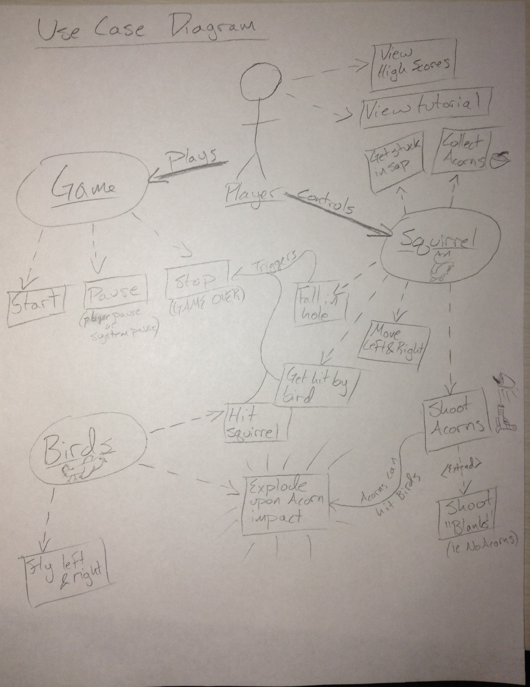

**Use Case 1: Game can start**

**Main success scenario**

In order to play the game the player of the game must be able to start the game from a few options including accessing high scores, and seeing a tutorial. When the player decides they want to start the game the application should take them to the main game screen and wait for a countdown to start the actual game play, so that the user has time to get ready.

**Use Case 2: Squirrel can move left and right as he moves up the tree**

**Primary Actor:** Squirrel

**Stakeholders & Interest:** Player,Acorns, Birds, Holes

**Preconditions:** The game has been started and Squirrel is rendered

**Post conditions:** Squirrel has moved to the desired destination

**Main Success Scenario:** Player has moved the squirrel to correct position

**Extensions:** I) Squirrel hits the side of the tree, cannot move any farther

II) Squirrel hits obstacle and can no longer move

**Special Requirements:** The game must have been started, and is required for any fun.

**Technology:** The rendering action must not be affected by the underlying moving of the

squirrel (in speed or performance). The application will have to be able to access the accelerometer as well.

**Frequency:** This action is would be performed 60/s if the frame rate is that high for the

application, so very frequent.

**Use Case 3: Squirrel can collect acorns and avoid holes and birds.**

**Main success scenario**

In order to keep the game going the squirrel must be able to avoid holes and birds. In order to increase the player’s high score the squirrel must be able to collect acorns along the way. Since the squirrel will be able to move left and right the application must detect when the squirrel has collided with one of the objects (bird, hole or acorn) and behave properly. When a bird or hole is hit there will be some sort of animation representing this action and the game will stop, persisting a high score. When an acorn is hit, it will be added to the squirrels collection of acorns for later use and score bonus.

**Alternate Scenarios**

If a bird and an acorn and a hole all happen to be in the same location when the squirrel collides with them, the bird logic will override the hole logic which will override the acorn logic.